YOUR PAPER TITLE – two rows maximum

FULL First Author, FULL second Author
Company, institucion
Email coresponding author

Abstract
This document explains and demonstrates how to prepare your camera-ready manuscript. A brief content of the contribution is given in the range of 5 - 10 lines. Times New Roman font, size 12, italics, lowercase letters will be used. All manuscripts must be in English.

Keywords
List the keywords covered in your paper. These keywords will also be used by the publisher to produce a keyword index.

- INTRODUCTION
For the timely publication of the proceeding, the organizing committee asks the authors of the articles to process their contributions according to the above instructions. The authors will supply the text part with relevant figures, graphs, diagrams and tables in the final graphic editing. The article must be prepared in a Word document, or another compatible program and submitted to the organizer in data form by e-mail to the address: radka.navratilova@cvut.cz.
Images can be delivered in data form in jpg, tiff, eps, bmp, etc. format (minimum resolution 300 dpi). The resulting format of the proceeding is A5, and therefore it is necessary to choose a sufficient size of images, graphs and tables to maintain readability.
- TABLE OF CONTENTS
  - DOCUMENT
    - PARAGRAPH
Paragraphs should be written in Times New Roman font, size 12 and right-aligned with possible hyphenation. Individual paragraphs are separated from each other by one line. If a paragraph has its own title, it is not separated by a line between the title and the rest of the text. A bold font is used for the title of the paragraph.
- DEADLINE AND PAYMENT
The deadline for submitting all documents is 1 September 2025. After this deadline, the organizer does not guarantee publication in the proceedings.
If the fee is not paid by October 20, 2025, the article will not be printed in the journal WTA.
- EQUATIONS
Equations (refer with: Eq. 1, Eq. 2, ...) should be indented 5 mm (0.2"). There should be one line of space above the equation and one line of space below it before the text continues. The equations have to be numbered sequentially, and the number put in parentheses at the right-hand edge of the text. Equations should be punctuated as if they were an ordinary part of the text. Punctuation appears after the equation but before the equation number, e.g.
c² = a² + b². (1)
- FIGURES AND TABLES
Figures, graphs, diagrams, formulas or tables are inserted between the appropriate paragraphs with a single line separation, or they can be placed in a paragraph and allowed to flow around the text, or placed consecutively at the end of the article.
Table. 1:data

For each of them, there is a descriptive label, for which the font Times New Roman, size 12 points, italics, small letters is used. The author decides on the place of inclusion of images and tables. Wrap them with text, or place them one behind the other at the end of the article.
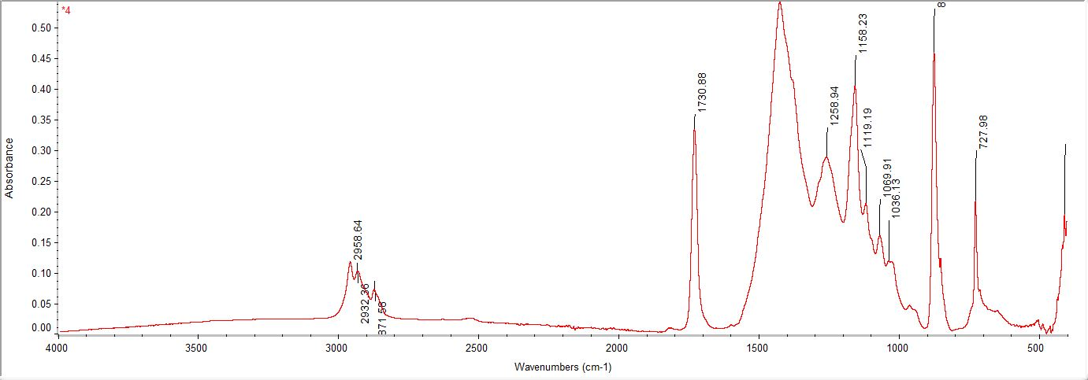
Fig. 1:Spectrum
- CONCLUSION
Please send the article to the organizer's address (radka.navratilova@cvut.cz) no later than 1 September 2025. Authors who do not follow the instructions will not have their articles printed. Please keep to the deadline.

ACKNOWLEDGMENTS
The results presented in the article were obtained as part of the project …

REFERENCES
[1] Baily, G., Benoit, C. Talking Machines. Theory, Models and Design. 1st ed. Amsterdam: Elsevier, 1998. 320 p. International Series in Automatisation. ISBN 80-214-256-4
[2] Baily, G., Benoit, C. Talking Machines. Theory, Models and Design. J. of New Ways in Comm. 1998, vol. 1, no. 5, p. 126-230.

